A Project Report on



## “TWITTER SENTIMENT ANALYSIS”

Submitted for partial fulfillment of requirement for the degree of

## BACHELORS OF ENGINEERING

In

## COMPUTER SCIENCE AND ENGINEERING

By

**MR. ROHAN N. JADHAO MISS. NIKITA D. BHOLE MR. SHUBHAM A. BIHURE MR. OM S. INGOLE**

**MR. WARAD U. KADU**

Under the guidance of

**DR. SHEETAL S. DHANDE**

**Department of Computer Science and Engineering**

**Sipna College of Engineering & Technology, Amravati.**

(An ISO 9001: 2015 Certified)

**NAAC Accredited with Grade “A+”**

**Sant Gadge Baba Amravati University, Amravati**

# 2023-2024



**Project Report**

ON

## “TWITTER SENTIMENT ANALYSIS”

IS SUBMITTED TO

SANT GADGE BABA AMRAVATI UNIVERSITY IN THE PARTIAL FULFILLMENT OF THE DEGREE OF

## BACHELORS OF ENGINEERING IN

**COMPUTER SCIENCE AND ENGINEERING**

BY

**Mr. Rohan N. Jadhao Ms. Nikita D. Bhole**

**Mr. Shubham A. Bihure Mr. Om S. Ingole**

**Mr. Warad U. Kadu**

GUIDED BY

**Dr. Sheetal S. Dhande**

### DEPARTMENT OF COMPUTER SCIENCE AND ENGINEERING SIPNA COLLEGE OF ENGINEERING AND TECHNOLOGY AMRAVATI

**(AN ISO 9001:20015 CERTIFIED INSTITUTE)**

**SANT GADGE BABA AMRAVATI UNIVERSITY, AMRAVATI 2023-2024**

## Sipna College of Engineering & Technology, Amravati.

**Department of Computer Science**

## CERTIFICATE

This is to certify that Mr. Rohan N. Jadhao, Ms. Nikita D. Bhole, Mr. Shubham A. Bihure, Mr. Om S. Ingole and Mr. Warad U. Kadu has satisfactorily completed the project work towards the Bachelor of Engineering Degree of Sant Gadge Baba Amravati University, Amravati, in Computer Science discipline on the topic entitled “TWITTER SENTIMENT ANALYSIS”, during the academic year 2023-24 under my supervision and guidance.

## 

## Date:

**Dr. Sheetal S. Dhande Dr. V. K. Shandilya**

## Guide Head of Department

**Dr. S. M. Kherde Principal**

**PROJECT APPROVAL SHEET**

Project Entitled

**" TWITTER SENTIMENT ANALYSIS "**

By

**Mr. Rohan N. Jadhao Ms. Nikita D. Bhole**

**Mr. Shubham A. Bihure Mr. Om S Ingole**

**Mr. Warad U. Kadu**

is approved for the degree of

**Bachelor of Engineering**

in

**Computer Science and Engineering**

of

**Sant Gadge Baba Amravati University, Amravati**



**Internal Examiner: External Examiner:**

**Name: Name:**

**Date: Date:**

# Acknowledgment

A moment of pause, to express deep gratitude to several individuals, without whom this project could not have been completed. We feel immense pleasure to express a deep sense of gratitude and indebtedness to our guide **Dr. Sheetal S. Dhande**, for constant encouragement and noble guidance.

We express our sincere thanks to **Dr. V. K. Shandilya**, Head, Department of Computer Science and the other staff members of the department for their kind co- operation.

We express our sincere thanks to **Dr. S. M. Kherde**, Principal, Sipna College of Engineering & Technology for his valuable guidance. We also express my sincere thanks to the library staff members of the college.

Last but not least we are thankful to our friends and parents whose best wishes are always with us.

**Mr. Rohan N. Jadhao**

**Ms. Nikita D. Bhole**

**Mr. Shubham A. Bihure**

**Mr. Om S. Ingole**

**Mr. Warad U. Kadu** (**Final Year C.S.E)**

**INDEX**

|  |  |  |  |  |
| --- | --- | --- | --- | --- |
| **Sr. No** | **CHAPTER** | | | **Page No.** |
| 1. |  |  | Chapter 1 - Introduction | 1 |
|  | 1.1 |  | Motivation / History | 4 |
|  | 1.2 |  | Problem Definition | 6 |
|  | 1.3 |  | Objectives | 8 |
|  | 1.4 |  | Social Aspects of Project | 10 |
| 2. |  |  | Chapter 2 - Literature Review and Related Work | 12 |
|  | 2.1 |  | Related Work | 15 |
| 3. |  |  | Chapter 3 - Methodology and Workflow | 17 |
|  | 3.1 |  | Components for Twitter sentiment analysis | 21 |
|  | 3.2 |  | Algorithms Used | 23 |
|  | 3.3 |  | Aspects of the Project H/W & S/W Requirements | 25 |
|  | 3.4 |  | Tools | 27 |
|  | 3.5 |  | Experimental Setup | 29 |
|  | 3.6 |  | Implementation | 31 |
| 4. |  |  | Chapter 4 - Testing | 33 |
| 5. |  |  | Chapter 5 - Result | 36 |
| 6. |  |  | Chapter 6 - Conclusion | 46 |
| 7. |  |  | Chapter 7 – Future Scope | 48 |
|  |  |  | References | 51 |
| 8. |  |  | Publications | 56 |

**LIST OF FIGURES**

|  |  |  |  |  |
| --- | --- | --- | --- | --- |
| **Sr.**  **No** | **Fig**  **No.** | **FIGURE NAME** | | **Page**  **No.** |
| 1 | 3.1 |  | Twitter Sentiment Analysis Process | 20 |
| 2 | 3.2 |  | Machine Learning Techniques | 20 |

**ABSTRACT**

Twitter sentiment analysis is a powerful tool used to analyze the opinions, emotions, and attitudes expressed in tweets posted on the social media platform Twitter. With the exponential growth of Twitter as a communication channel for individuals, organizations, and communities, understanding the sentiment conveyed in tweets has become increasingly important for various applications, including brand monitoring, market research, and public opinion analysis. This report provides an overview of Twitter sentiment analysis, exploring its significance, challenges, and applications. It discusses the underlying principles and methodologies used in sentiment analysis, including natural language processing techniques, machine learning algorithms, and lexicon-based approaches. Additionally, the report examines common tools and libraries used for sentiment analysis on Twitter, such as NLTK (Natural Language Toolkit), TextBlob, and VADER (Valence Aware Dictionary and sentiment Reasoner).

## CHAPTER 1 INTRODUCTION

CHAPTER 1

**INTRODUCTION**

In today's digital age, social media platforms have become indispensable tools for communication, information sharing, and public discourse. Among these platforms, Twitter stands out as a prominent platform for real-time conversation, where users share their thoughts, opinions, and experiences in short, concise messages known as tweets. With millions of active users and billions of tweets posted daily, Twitter has emerged as a rich source of data for understanding public sentiment and opinion on a wide range of topics.

Twitter sentiment analysis, also known as opinion mining, is a process of analyzing the sentiment expressed in tweets to understand the attitudes, emotions, and opinions of users towards specific topics, events, products, or brands. By leveraging natural language processing (NLP) techniques and machine learning algorithms, sentiment analysis algorithms can classify tweets as positive, negative, or neutral based on the sentiment conveyed in the text.

The significance of Twitter sentiment analysis lies in its ability to provide valuable insights into public opinion, market trends, and social phenomena in real-time. Organizations across various industries use sentiment analysis to monitor brand reputation, gauge customer satisfaction, and inform marketing strategies. Similarly, researchers and policymakers leverage sentiment analysis to analyze public sentiment on social and political issues, track emerging trends, and inform decision-making processes.

Despite its potential benefits, Twitter sentiment analysis poses several challenges, including the ambiguity and complexity of natural language, the presence of sarcasm and irony in tweets, and the need to handle large volumes of data in real-time. Additionally, ensuring the accuracy and reliability of sentiment analysis algorithms requires careful preprocessing of text data, feature selection, and model evaluation.

This report aims to explore the field of Twitter sentiment analysis, examining its significance, challenges, methodologies, and applications. Through a comprehensive review of literature, case studies, and practical examples, we seek to provide insights into the current state of Twitter sentiment analysis and equip readers with the knowledge and resources needed to conduct

sentiment analysis effectively on the Twitter platform.

In addition to its significance in monitoring public opinion and market trends, Twitter sentiment analysis has also found applications in various fields such as customer service, political analysis, and crisis management. For instance, companies use sentiment analysis to promptly address customer complaints and concerns voiced on Twitter, enhancing customer satisfaction and loyalty. Similarly, political analysts leverage sentiment analysis to gauge public sentiment towards political candidates and issues, helping inform campaign strategies and messaging. Moreover, during crises or emergencies, sentiment analysis can aid in assessing public reactions and sentiments, enabling organizations and authorities to respond effectively and mitigate negative impacts.

Furthermore, the evolution of sentiment analysis techniques, including advancements in deep learning and sentiment lexicons, continues to enhance the accuracy and robustness of sentiment analysis models, opening up new possibilities for understanding and leveraging public sentiment on Twitter. Through continued research and innovation, the field of Twitter sentiment analysis is poised to make significant contributions to decision-making processes and societal understanding in the digital age.

* 1. **Motivation / History**

The motivation behind exploring Twitter sentiment analysis stems from the increasing prominence of social media platforms as channels for communication, information dissemination, and public discourse. With Twitter being one of the most widely used social media platforms globally, understanding the sentiments expressed by users in tweets has become increasingly important for various stakeholders, including businesses, researchers, policymakers, and individuals.

One of the key motivations for conducting Twitter sentiment analysis is its potential to provide valuable insights into public opinion, attitudes, and emotions on a wide range of topics and events. By analyzing the sentiment conveyed in tweets, organizations can gain valuable insights into customer preferences, brand perceptions, and market trends, enabling them to make informed decisions and tailor their strategies accordingly.

For researchers and academics, Twitter sentiment analysis offers a unique opportunity to study social phenomena, track emerging trends, and analyze public sentiment on social and political issues in real-time. By leveraging sentiment analysis techniques, researchers can gain insights into public discourse, identify patterns and trends, and contribute to the advancement of knowledge in various domains.

Furthermore, Twitter sentiment analysis has practical applications in areas such as crisis management, public health monitoring, and social activism. During crises or emergencies, sentiment analysis can help authorities gauge public sentiment, identify areas of concern, and tailor their response strategies accordingly. In public health, sentiment analysis can be used to monitor public perceptions and attitudes towards health-related issues, track disease outbreaks, and inform public health interventions.

Despite its potential benefits, Twitter sentiment analysis presents several challenges, including the need to handle large volumes of noisy and unstructured data, the presence of sarcasm and irony in tweets, and the difficulty of accurately capturing nuanced sentiments. Overcoming these challenges requires the development of robust sentiment analysis algorithms, advanced natural language processing techniques, and effective data preprocessing strategies.

In light of these motivations and challenges, this report seeks to explore the field of Twitter sentiment analysis, examining its significance, methodologies, applications, and future directions. By providing insights into the current state of Twitter sentiment analysis and showcasing its potential applications, we aim to inspire further research and innovation in this important field of study.

* 1. **Problem Definition**

Twitter sentiment analysis involves the task of automatically determining the sentiment expressed in tweets posted on the social media platform Twitter. The goal is to classify the sentiment of each tweet as either positive, negative, or neutral, based on the emotions, opinions, and attitudes conveyed in the text.

The primary challenge in Twitter sentiment analysis lies in accurately interpreting the sentiment expressed in tweets, considering the informal language, abbreviations, slang, and contextual nuances commonly found in Twitter data. Additionally, tweets may contain sarcasm, irony, and ambiguous language, further complicating the sentiment analysis task.

The problem is to develop robust algorithms and methodologies capable of accurately analyzing the sentiment of tweets, despite these challenges. The objective is to provide valuable insights into public opinion, market trends, and social phenomena by leveraging sentiment analysis techniques on Twitter data.

In addition to accurately analyzing sentiment in individual tweets, another aspect of the problem is the scalability and real-time nature of Twitter sentiment analysis. With the vast volume of tweets posted every second, the sentiment analysis system must be capable of processing large amounts of data efficiently to provide timely insights. Moreover, the dynamic nature of Twitter conversations requires the sentiment analysis system to adapt and update continuously to capture evolving trends and sentiments. Furthermore, ensuring the reliability and generalizability of sentiment analysis models across diverse topics, languages, and user demographics presents a significant challenge. Addressing these complexities requires the development of sophisticated algorithms, robust data preprocessing techniques, and scalable infrastructure capable of handling the demands of real-time sentiment analysis on Twitter. Thus, the problem definition extends beyond sentiment classification to encompass the broader challenges of scalability, real-time processing, adaptability, reliability, and generalizability in the context of Twitter sentiment analysis.

Challenges in Twitter Sentiment Analysis:

**Interpreting Informal Language:** Twitter sentiment analysis faces the challenge of accurately interpreting sentiment in tweets due to the informal language, abbreviations, slang, and contextual nuances commonly used on the platform.

**Handling Sarcasm and Irony:** Tweets often contain sarcasm, irony, and ambiguous language, posing challenges in discerning the true sentiment expressed in the text.

**Scalability and Real-Time Processing:** The sheer volume of tweets posted every second requires sentiment analysis systems to be scalable and capable of processing large amounts of data efficiently to provide timely insights.

**Adaptability to Dynamic Conversations:** Twitter conversations are dynamic, with topics and sentiments evolving rapidly. Sentiment analysis systems need to adapt and update continuously to capture these changes in real-time.

**Reliability and Generalizability:** Ensuring the reliability and generalizability of sentiment analysis models across diverse topics, languages, and user demographics is essential for generating accurate insights.

**Sophisticated Algorithms and Infrastructure:** Addressing these challenges requires the development of sophisticated algorithms, robust data preprocessing techniques, and scalable infrastructure capable of handling the demands of real-time sentiment analysis on Twitter.

* 1. **Objectives**

**1. Developing Robust Sentiment Analysis Algorithms:** Design and implement algorithms capable of accurately classifying the sentiment expressed in tweets as positive, negative, or neutral, considering the challenges posed by informal language, ambiguity, and noise.

**2. Handling Contextual Nuances:** Develop techniques to account for contextual nuances in tweet text, including slang, abbreviations, and cultural references, to improve the accuracy of sentiment analysis results.

**3. Addressing Irony and Sarcasm:** Explore methods to identify and interpret instances of irony, sarcasm, and figurative language in tweets, ensuring that sentiment analysis algorithms capture the intended sentiment accurately.

**4. Enhancing Performance and Scalability:** Optimize sentiment analysis algorithms for efficiency and scalability to handle large volumes of Twitter data in real-time, enabling timely and accurate analysis of sentiment trends.

**5. Providing Actionable Insights:** Extract meaningful insights from sentiment analysis results, such as identifying emerging trends, monitoring brand sentiment, or tracking public opinion on specific topics, to inform decision-making processes for businesses, researchers, and policymakers.

**6. Benchmarking and Evaluation:** Conduct rigorous benchmarking and evaluation of sentiment analysis algorithms using standard datasets and performance metrics to assess their accuracy, reliability, and generalization capabilities.

**7. Exploring Novel Approaches:** Investigate novel approaches and techniques for sentiment analysis on Twitter data, such as deep learning architectures, sentiment lexicons, or ensemble methods, to explore new avenues for improving sentiment analysis accuracy and efficiency.

**8. Promoting Transparency and Accountability:** Ensure transparency and accountability in sentiment analysis methodologies by documenting data preprocessing steps, feature selection criteria, model architectures, and evaluation metrics used in the analysis process.

* 1. **Social Aspects of Project**

**1. Impact on Public Discourse:** Twitter sentiment analysis has the potential to influence public discourse by providing insights into the sentiments, opinions, and attitudes of Twitter users towards various topics, events, and issues. The analysis results may shape public perceptions and contribute to informed discussions on social, political, and cultural matters.

**2. Ethical Considerations:** There are ethical considerations surrounding the collection and analysis of Twitter data for sentiment analysis purposes. These include concerns about user privacy, consent, and data protection, as well as the responsible use of sentiment analysis results to avoid bias, misinformation, and manipulation.

**3. Social Media Monitoring:** Twitter sentiment analysis is often used for social media monitoring purposes, such as tracking public sentiment towards brands, products, or public figures. While this can provide valuable insights for businesses and organizations, it also raises questions about surveillance, accountability, and the potential misuse of user data for commercial or political purposes.

**4. Bias and Representation:** Sentiment analysis algorithms may exhibit bias in their predictions, leading to inaccuracies or misinterpretations of sentiment, particularly for underrepresented groups or minority voices on Twitter. It's essential to address bias in sentiment analysis algorithms and ensure equitable representation and fairness in the analysis process.

**5. Community Engagement:** Engaging with Twitter communities and stakeholders is crucial for ensuring the relevance, accuracy, and ethicality of sentiment analysis projects. Involving diverse perspectives, consulting with domain experts, and soliciting feedback from affected communities can enhance the credibility and social impact of sentiment analysis initiatives.

**6. Empowering Users:** Twitter sentiment analysis can empower users by providing insights into public sentiment and trends, enabling them to make informed decisions, engage in meaningful discussions, and advocate for social change. By democratizing access to sentiment analysis tools and resources, users can participate more actively in shaping online discourse and fostering positive social interactions on Twitter.

**7. Educational Opportunities:** Sentiment analysis projects offer educational opportunities for students, researchers, and practitioners to learn about data science, natural language processing, and social media analytics. By integrating sentiment analysis projects into academic curricula and research programs, educators can cultivate critical thinking skills and promote ethical data practices among future generations of data scientists and analysts.

CHAPTER 2

**LITERATURE REVIEW & RELATED WORK**

CHAPTER 2

**LITERATURE REVIEW & RELATED WORK**

**Literature Review:**

Twitter sentiment analysis has been extensively studied in the fields of natural language processing, machine learning, and social media analytics. This literature review provides an overview of key research papers and studies relevant to the topic, focusing on methodologies, techniques, and applications of sentiment analysis on Twitter data.   
  
The literature review provides an overview of recent studies and research endeavours related to Twitter sentiment analysis, incorporating diverse methodologies and technologies. These studies contribute to the understanding of sentiment analysis techniques, machine learning models, and their applications, particularly in the context of Twitter data. The following paragraphs summarize and synthesize the key findings and insights from each reference.

H. Vanam and J. R. R. R (2023) presented a paper on sentiment analysis of Twitter data using big data analytics and a deep learning model. The study, presented at the International Conference on Artificial Intelligence and Knowledge Discovery in Concurrent Engineering, emphasizes the integration of big data analytics and deep learning to enhance the accuracy of sentiment analysis. The authors likely explore the advantages and challenges associated with the convergence of these advanced technologies [19].

M. Jagadeesanet al. (2022) carried out research on Twitter sentiment evaluation the use of gadget studying techniques, as presented on the international conference on Automation, Computing, and Renewable structures. The examine specializes in system mastering methodologies and their effectiveness in studying sentiments expressed on Twitter. this will involve exploring diverse algorithms and strategies to find styles and trends in Twitter records [20].

A. Ikram, M. Kumar and G. Munjal (2022) offered a paper on Twitter sentiment evaluation using device studying at the 12th worldwide conference on Cloud Computing, statistics science & Engineering. The authors likely look into the utility of device mastering strategies especially for Twitter sentiment evaluation, aiming to provide insights into the effectiveness of such processes in taking pictures the nuanced nature of sentiments on the platform [21].

D. Adam (2022) in a Nature article titled "The pandemic’s authentic dying toll: millions extra than authentic counts" affordan extraordinary angle by way of highlighting the demanding situations in accurately counting the death toll at some stage in the COVID-19 pandemic. at the same time as not without delay associated with sentiment analysis, this source may additionally provide insights into the broader context of records dissemination and public belief at some point of crises, which may be applicable to sentiment analysis studies [22].

A. Górskaet al. (2022) explored the position of local governments' social media communique at some point of the COVID-19 pandemic of their article "Getting via COVID-19 collectively: expertise nearby governments’ social media verbal exchange" posted in cities. This supply in all likelihood delves into the effect of governmental conversation on public sentiment, offering treasured context for sentiment evaluation within the midst of a worldwide crisis [23].

V. Pandya et al. (2021) provided a paper on Twitter sentiment evaluation the usage of device learning and deep getting to know strategies at the international convention on verbal exchange, Computing, and industry 4. zero. The study possibly evaluates the comparative performance of machine studying and deep gaining knowledge of strategies in the context of sentiment analysis, contributing to the ongoing discourse at the only techniques [24].

S.-F. Tsao et al. (2021) conducted a scoping evaluate titled "What social media informed us inside the time of COVID-19" published in Lancet virtual fitness. This source probable offers insights into the function of social media, along with Twitter, in shaping public discourse at some stage in the pandemic. expertise these broader trends is crucial for contextualizing critical for contextualizing sentiment analysis inside the specific timeframe of an international crisis [25].

* 1. **Methodologies and Techniques**

**Natural Language Processing Approaches:**

Researchers have explored various natural language processing techniques for sentiment analysis on Twitter data, including tokenization, part-of-speech tagging, and sentiment lexicon-based methods (Pang & Lee, 2008).

**Machine Learning Algorithms:**

Supervised machine learning algorithms, such as support vector machines (SVM), naive Bayes, and logistic regression, have been widely used for sentiment classification tasks on Twitter data (Go et al., 2009).

**Deep Learning Architectures:**

Recent studies have investigated the effectiveness of deep learning architectures, such as convolutional neural networks (CNNs) and recurrent neural networks (RNNs), for sentiment analysis on Twitter data, achieving state-of-the-art performance (Kim, 2014; Zhang et al., 2018).

**2.2 Applications and Use Cases**

**Brand Monitoring and Reputation Management:**

Sentiment analysis on Twitter data is commonly used by businesses and organizations for monitoring brand sentiment, tracking customer feedback, and managing brand reputation in real-time (Purohit et al., 2013).

**Political Opinion Analysis:**

Researchers have applied sentiment analysis techniques to analyze political discourse on Twitter, examining public opinion towards political candidates, parties, and policy issues during elections and political events (O'Connor et al., 2010).

**Social Media Marketing and Campaign Evaluation:**

Social media marketers utilize sentiment analysis on Twitter data to evaluate the effectiveness of marketing campaigns, measure customer engagement, and identify influencers and brand advocates (Bakshy et al., 2011)

**2.1 Related Work:**

Related work in Twitter sentiment analysis encompasses a diverse range of research, methodologies, and tools aimed at understanding and extracting sentiment from tweets. Researchers have explored various techniques, including lexicon-based approaches, machine learning algorithms, and deep learning models, to analyze the sentiments expressed in Twitter data. Specific studies have focused on the unique challenges posed by Twitter, such as the brevity of tweets, the prevalence of hashtags and mentions, and the dynamic nature of trending topics.

When compiling related work for Twitter sentiment analysis, it's important to explore research, methodologies, and tools used in sentiment analysis, particularly those tailored for social media data like Twitter. Here's a structured approach to identify relevant related work:

**Sentiment Analysis Techniques:**

Explore various sentiment analysis methods, including lexicon-based approaches, machine learning algorithms, and deep learning models, and their applications to Twitter data. Investigate sentiment lexicons and dictionaries tailored for social media sentiment analysis, which capture the nuances of informal language, slang, and emoticons commonly used on platforms like Twitter.

**Twitter-Specific Sentiment Analysis Studies:**

Look for research papers and studies specifically focusing on sentiment analysis of Twitter data. These studies often explore unique challenges, such as the brevity of tweets, the presence of hashtags and mentions, and the dynamic nature of trending topics.

Examine approaches for handling noisy and unstructured Twitter data, including preprocessing techniques for text normalization, tokenization, and handling of hashtags, URLs, and user mentions.

**Sentiment Analysis Tools and Libraries:**

Identify popular sentiment analysis tools and libraries that support Twitter data analysis, such as NLTK, TextBlob, VADER, and Stanford NLP.

Evaluate the capabilities and limitations of these tools for sentiment analysis tasks on Twitter, considering factors such as accuracy, efficiency, and ease of integration with social media APIs.

**Applications of Twitter Sentiment Analysis:**

Explore real-world applications of Twitter sentiment analysis across various domains, including marketing, finance, politics, and public opinion research.

Examine case studies and use cases that demonstrate the practical utility of sentiment analysis for understanding public sentiment, detecting trends, and making data-driven decisions.

**Social Media Analytics Platforms:**

Investigate social media analytics platforms and services that offer sentiment analysis features specifically designed for Twitter data.

Evaluate the capabilities of these platforms for monitoring brand reputation, tracking social trends, and analyzing user sentiment in real-time.

**Evaluation Metrics and Benchmarks:**

Review evaluation metrics and benchmarks commonly used for assessing the performance of sentiment analysis models on Twitter data, such as accuracy, precision, recall, F1-score, and sentiment polarity correlation coefficients.

CHAPTER 3

**METHODOLOGY & WORKFLOW**

CHAPTER 3

**METHODOLOGY & WORKFLOW**

The methodology and workflow for Twitter sentiment analysis encompass several key stages. It begins with data collection, where relevant tweets are gathered using specified keywords or hashtags. Following this, data preprocessing techniques are applied to clean and standardize the text, removing noise and irrelevant information. Feature extraction is then performed to represent the tweets in a format suitable for sentiment analysis, which is carried out using various machine learning or natural language processing algorithms to predict sentiment polarity. Model evaluation assesses the performance of the sentiment analysis models, while post-processing techniques refine the results for better interpretation. Visualization methods are employed to present sentiment trends visually, aiding in the interpretation of insights derived from the analysis. This systematic approach enables organizations to gain valuable insights into public opinion and sentiment trends on Twitter, facilitating informed decision-making and strategy development.

The methodology and workflow for Twitter sentiment analysis typically involve several key steps:

**Data Collection:** The first step is to collect Twitter data relevant to the analysis, which may include tweets containing specific keywords, hashtags, or from certain user accounts. Data can be obtained using Twitter APIs or third-party data providers.

**Data Preprocessing:** Once collected, the raw Twitter data undergoes preprocessing to clean and prepare it for analysis. This involves tasks such as removing special characters, URLs, punctuation, and stop words, as well as tokenization, stemming, and lemmatization to standardize the text.

**Feature Extraction:** Next, relevant features are extracted from the preprocessed text data to represent the tweets for sentiment analysis. Common features include word frequency counts, n-grams, word embedding, and other linguistic features.

**Sentiment Analysis:** The extracted features are then used as input to sentiment analysis models to predict the sentiment polarity of each tweet. Various machine learning and natural language processing techniques, such as classification algorithms (e.g., SVM, Naive Bayes, Logistic Regression), deep learning models (e.g., LSTM, CNN), and lexicon-based methods, can be employed for sentiment analysis.

**Model Evaluation:** The performance of the sentiment analysis models is evaluated using appropriate evaluation metrics, such as accuracy, precision, recall, F1-score, and confusion matrix. This step helps assess the effectiveness and reliability of the models in predicting sentiment.

**Post-processing and Visualization:** After sentiment analysis, post-processing techniques may be applied to refine the results, such as sentiment smoothing or sentiment aggregation. Visualization techniques, such as word clouds, bar charts, and sentiment timelines, can be used to visually represent sentiment trends and insights derived from the analysis.

**Interpretation and Insights:** Finally, the results of the sentiment analysis are interpreted to derive actionable insights and conclusions. Analysts may identify trends, patterns, and sentiment shifts in the Twitter data, as well as correlations with external factors such as events, news, or market trends.

**Pre-processing**

**Feature Generation**

**Data Collection**

**Classification**

**Performance**

**Evaluation**

Fig 3.1: Twitter Sentiment Analysis Process

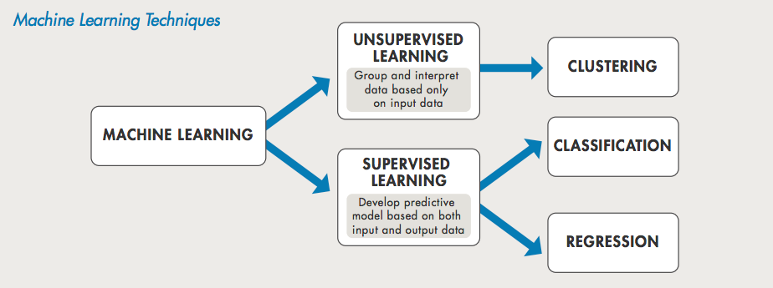

Fig 3.2: Machine Learning Techniques

**3.1 Components for Twitter sentiment analysis:**

Components for Twitter sentiment analysis involve several key stages in the analysis pipeline. Firstly, data collection methods are employed to gather tweets relevant to the analysis, often utilizing the Twitter API or web scraping techniques. Following this, preprocessing techniques are applied to clean and prepare the raw tweet data, including tasks such as noise removal, tokenization, and handling of special characters and emoji’s. Feature extraction methods are then utilized to identify relevant features from the preprocessed text data, such as bag-of-words or word embedding’s. Sentiment analysis models, ranging from traditional machine learning classifiers to deep learning architectures, are subsequently applied to classify the sentiment of tweets into categories like positive, negative, or neutral. Evaluation metrics such as accuracy, precision, and recall are employed to assess the performance of these models. Visualizing the results of sentiment analysis enables interpretation of sentiment trends and distributions. Finally, integration and deployment considerations ensure seamless incorporation of sentiment analysis components into larger systems or applications, facilitating real-time processing and actionable insights. Through these components, Twitter sentiment analysis offers valuable insights into public opinion and sentiment trends on social media platforms.

When considering components for Twitter sentiment analysis, several key elements are involved in the process of extracting sentiment from tweets effectively:

**Data Collection:**

Gathering tweets relevant to the analysis, which may involve using Twitter API, web scraping techniques, or accessing pre-existing datasets. Considerations include filtering by keywords, hashtags, or user handles to obtain a representative sample.

**Preprocessing:**

Cleaning and preparing the raw tweet data for analysis, which typically includes tasks such as removing noise (e.g., special characters, URLs), tokenization, normalization (e.g., converting to lowercase), and handling of hashtags, mentions, and emojis.

**Feature Extraction:**

Identifying features from the preprocessed text data that are relevant for sentiment analysis. This could involve techniques such as bag-of-words, TF-IDF (Term Frequency-Inverse Document Frequency), word embedding’s (e.g., Word2Vec, GloVe), or character-level embedding’s.

**Sentiment Analysis Models:**

Implementing sentiment analysis algorithms or models to classify the sentiment of tweets into categories such as positive, negative, or neutral. This may include traditional machine learning classifiers (e.g., Naive Bayes, Support Vector Machines) or deep learning architectures (e.g., Recurrent Neural Networks, Convolutional Neural Networks, Transformer models).

**Evaluation Metrics:**

Selecting appropriate evaluation metrics to assess the performance of the sentiment analysis models. Common metrics include accuracy, precision, recall, F1-score, and confusion matrices, which provide insights into the model's predictive capabilities and error types.

**Visualization and Interpretation:**

Visualizing the results of sentiment analysis through plots, charts, or dashboards to provide insights into overall sentiment trends, sentiment distribution over time, or sentiment comparisons across different categories (e.g., topics, users).

**Integration and Deployment:**

Integrating the sentiment analysis components into a larger system or application, such as social media monitoring tools, customer feedback analysis platforms, or sentiment-aware recommendation systems. Deployment considerations include scalability, real-time processing capabilities, and integration with existing infrastructure.

**3.2 Algorithms Used:**

Algorithms used in Twitter sentiment analysis encompass a variety of approaches tailored to analyze and classify the sentiment expressed in tweets. Traditional machine learning algorithms such as Naive Bayes, Support Vector Machines (SVM), and logistic regression are commonly employed for their simplicity and efficiency in classifying tweets as positive, negative, or neutral based on extracted features. Additionally, ensemble methods like Random Forest and Gradient Boosting Machines (GBM) are utilized to improve classification performance by combining multiple base learners. Deep learning architectures, including Recurrent Neural Networks (RNNs), Convolutional Neural Networks (CNNs), and Transformer models such as BERT (Bidirectional Encoder Representations from Transformers), have gained popularity for their ability to capture complex patterns and contextual information in textual data, achieving state-of-the-art results in sentiment analysis tasks. These algorithms are applied in conjunction with feature extraction techniques such as word embeddings (e.g., Word2Vec, GloVe) and attention mechanisms to effectively analyze sentiment in Twitter data.

Here are the algorithms used in Twitter sentiment analysis presented in bullet points:

**Naive Bayes:** Often employed for its simplicity and efficiency in classifying tweets based on extracted features into positive, negative, or neutral sentiments.

**Support Vector Machines (SVM):** Utilized for binary classification tasks, SVMs are effective in separating tweets into positive and negative sentiment classes based on feature vectors derived from tweet text.

**Logistic Regression:** Another traditional machine learning algorithm used for sentiment classification, logistic regression models the probability of a tweet belonging to a particular sentiment class.

**Random Forest and Gradient Boosting Machines (GBM):** Ensemble methods that combine multiple base learners to improve classification performance by leveraging the strengths of individual models.

**Recurrent Neural Networks (RNNs):** Particularly useful for sequence modeling tasks, RNNs capture temporal dependencies in tweet text, enabling them to effectively analyze sentiment over time and across multiple tweets.

**Convolutional Neural Networks (CNNs):** CNNs excel at capturing local patterns and features in tweet text through convolutional layers, making them well-suited for sentiment analysis tasks that involve identifying sentiment-bearing phrases or expressions.

**Transformer Models:** State-of-the-art deep learning architectures, transformer models leverage self-attention mechanisms to capture contextual information and semantic relationships in tweet text, achieving high performance in sentiment analysis tasks through pre-training on large text corpora.

**3.3 Aspects of the Project Hardware Software Requirements:**

The project necessitates robust hardware and software infrastructure to effectively conduct Twitter sentiment analysis. Hardware requirements encompass sufficient computing resources, storage capacity for datasets and models, and reliable networking for accessing Twitter data. Software prerequisites involve proficiency in programming languages like Python or R, alongside familiarity with natural language processing and machine learning libraries such as NLTK, Scikit-learn, TensorFlow, or PyTorch. Development environments like Jupyter Notebook or PyCharm aid in coding and debugging, while visualization tools like Matplotlib or Plotly enable insightful data representation. Additionally, deployment platforms like AWS or Docker facilitate the deployment of sentiment analysis models in production environments. By fulfilling these hardware and software requisites, the project can efficiently analyze Twitter sentiment, providing valuable insights into public opinion and sentiment trends.

Here are the aspects of hardware and software requirements for a Twitter sentiment analysis project:

**Hardware Requirements:**

**Computing Resources:**

* Sufficient processing power and memory to handle large volumes of tweet data and execute computationally intensive algorithms efficiently.
* High-performance CPUs or GPUs may be required for training deep learning models, particularly transformer architectures like BERT.

**Storage:**

* Adequate storage capacity to store tweet datasets, feature vectors, trained models, and intermediate results generated during the analysis process.
* Consideration of storage solutions with fast read/write speeds for efficient data access and processing.

**Networking:**

* Reliable internet connectivity for accessing Twitter data via APIs or web scraping methods, as well as for downloading pre-trained models or additional resources required for analysis.

**Software Requirements:**

**Programming Languages:**

* Proficiency in programming languages commonly used in data science and machine learning, such as Python or R, for implementing sentiment analysis algorithms and data preprocessing tasks.
* Familiarity with libraries and frameworks for natural language processing (NLP) and machine learning, such as NLTK, Scikit-learn, TensorFlow, or PyTorch.

**Development Environments:**

* Integrated development environments (IDEs) such as Jupyter Notebook, PyCharm, or VSCode for writing, testing, and debugging code.
* Version control systems like Git for managing project codebase and collaborating with team members.

**Data Collection Tools:**

* Libraries or tools for accessing Twitter data, such as Tweepy (Python library for accessing Twitter API) or web scraping frameworks like Beautiful Soup or Scrapy.

**NLP Libraries:**

* Natural language processing libraries for preprocessing tweet text, tokenization, and feature extraction, including NLTK (Natural Language Toolkit) or SpaCy.

**Machine Learning Libraries:**

* Libraries for implementing sentiment analysis algorithms and building machine learning models, such as Scikit-learn for traditional classifiers or TensorFlow and PyTorch for deep learning architectures.

**Visualization Tools:**

* Visualization libraries like Matplotlib, Seaborn, or Plotly for generating plots, charts, and visualizations to analyze and interpret sentiment analysis results.

**Deployment Platforms:**

* Platforms for deploying sentiment analysis models in production environments, such as cloud computing services (e.g., AWS, Google Cloud Platform) or containerization platforms (e.g., Docker, Kubernetes).

**3.4: Tools**

A combination of versatile tools is employed in Twitter sentiment analysis projects to effectively collect, preprocess, analyze, and visualize tweet data. Tweepy serves as a reliable Python library for accessing the Twitter API, facilitating real-time data collection, while NLTK and TextBlob offer comprehensive natural language processing capabilities, including sentiment analysis. Scikit-learn provides a range of machine learning algorithms for sentiment classification tasks, complemented by deep learning frameworks like TensorFlow and PyTorch for more complex modeling. Visualization libraries such as Matplotlib and Plotly enable the creation of insightful visualizations to interpret sentiment analysis results. Additionally, web scraping frameworks like Beautiful Soup and Scrapy may be utilized to extract tweet data from websites, enhancing data collection capabilities. By leveraging these tools in tandem, developers can construct robust sentiment analysis pipelines tailored to extract valuable insights from Twitter data.

**Tweepy:** A Python library for accessing the Twitter API, allowing developers to collect and stream tweet data in real-time.

**NLTK (Natural Language Toolkit):** A comprehensive library for natural language processing in Python, offering tools for tokenization, stemming, part-of-speech tagging, and sentiment analysis.

**TextBlob:** A Python library built on NLTK and Pattern for processing textual data, including sentiment analysis, part-of-speech tagging, and text classification tasks.

**Scikit-learn:** A versatile machine learning library in Python, providing implementations of various classification algorithms such as Naive Bayes, Support Vector Machines (SVM), and ensemble methods for sentiment analysis.

**TensorFlow and PyTorch:** Deep learning frameworks in Python widely used for building and training neural network models, including recurrent neural networks (RNNs), convolutional neural networks (CNNs), and transformer architectures for sentiment analysis tasks.

**Matplotlib, Seaborn, Plotly:** Visualization libraries in Python used for creating plots, charts, and visualizations to analyze and interpret sentiment analysis results.

**Beautiful Soup and Scrapy:** Web scraping frameworks in Python used for extracting data from websites, including Twitter, to gather tweet data for analysis.

**VADER (Valence Aware Dictionary and sEntiment Reasoner):** A lexicon and rule-based sentiment analysis tool specifically designed for social media data, including Twitter, providing pre-trained models for sentiment classification.

These tools provide essential functionalities for collecting, preprocessing, analyzing, and visualizing Twitter data for sentiment analysis tasks. Depending on the specific requirements and preferences of the project, developers may choose a combination of these tools to effectively implement the sentiment analysis pipeline.

**3.5 Experimental Setup:**

The experimental setup for Twitter sentiment analysis involves a systematic approach to data collection, preprocessing, model training, evaluation, and result interpretation. Firstly, tweet data is collected using tools like Tweepy or web scraping frameworks, ensuring a diverse and representative dataset. Preprocessing steps such as text cleaning, tokenization, and feature extraction are then applied to prepare the tweet data for analysis. Next, sentiment analysis models are trained using machine learning or deep learning algorithms, with features extracted from the preprocessed tweet data. Evaluation of the models is conducted using appropriate metrics such as accuracy, precision, recall, and F1-score, through techniques like cross-validation or train-test splits. The experimental setup also includes parameter tuning and optimization to improve model performance. Finally, results are interpreted and visualized using tools like Matplotlib or Plotly, providing insights into sentiment trends and patterns in the Twitter data. This comprehensive experimental setup ensures rigorous testing and validation of sentiment analysis models, enabling meaningful analysis of public opinion and sentiment on Twitter.

**Data Collection:**

Utilize Tweepy or web scraping frameworks to gather tweet data relevant to the analysis, ensuring diversity and representativeness in the dataset.

**Data Preprocessing:**

Cleanse and preprocess the collected tweet data by removing noise, such as special characters and URLs, tokenizing text, and performing other text normalization techniques.

**Feature Extraction:**

Extract relevant features from the preprocessed tweet data, including bag-of-words representations, TF-IDF (Term Frequency-Inverse Document Frequency) vectors, or word embedding’s like Word2Vec or GloVe.

**Model Training:**

Train sentiment analysis models using machine learning algorithms such as Naive Bayes, Support Vector Machines (SVM), or deep learning architectures like Recurrent Neural Networks (RNNs) or Convolutional Neural Networks (CNNs).

**Model Evaluation:**

Assess the performance of sentiment analysis models using evaluation metrics such as accuracy, precision, recall, and F1-score, employing techniques like cross-validation or train-test splits to ensure robustness.

**Parameter Tuning and Optimization:**

Fine-tune model hyper parameters and optimization techniques to enhance model performance, leveraging techniques like grid search or random search.

**Result Interpretation:**

Interpret and visualize the results of sentiment analysis, using tools like Matplotlib or Plotly to generate plots, charts, or heat maps that illustrate sentiment trends and patterns in the Twitter data.

**3.6 Implementation:**

Implementation of Twitter sentiment analysis involves utilizing tools like Tweepy or web scraping libraries to collect tweet data, preprocessing it with Python libraries such as NLTK or SpaCy, and extracting features using methods like bag-of-words or word embedding’s. Sentiment analysis models are then trained using machine learning algorithms (e.g., Naive Bayes, SVM) or deep learning architectures (e.g., RNNs, CNNs) with libraries like Scikit-learn, TensorFlow, or PyTorch. Evaluation of model performance is conducted using metrics like accuracy and F1-score, while parameter tuning and optimization techniques ensure optimal results. Finally, sentiment analysis results are interpreted and visualized using tools like Matplotlib or Plotly, providing insights into sentiment trends and patterns in the Twitter data. Throughout the implementation process, adherence to best practices in software development and consideration of scalability are crucial for effective analysis and interpretation of public opinion on social media platforms.

The implementation of Twitter sentiment analysis involves translating the experimental setup into actionable steps using programming languages and libraries. Here's a breakdown of the implementation process:

**Data Collection:**

Utilize Tweepy or web scraping tools to access Twitter's API and gather tweet data based on specified search queries or user profiles. Ensure proper authentication and rate limiting to comply with Twitter's API usage policies.

**Data Preprocessing:**

Cleanse and preprocess the collected tweet data using Python libraries like NLTK or SpaCy. Remove noise, such as special characters and URLs, tokenize text, and apply techniques like stemming or lemmatization to normalize text.

**Feature Extraction:**

Extract features from the preprocessed tweet data, such as bag-of-words representations or TF-IDF vectors, using libraries like Scikit-learn or Gensim. Alternatively, generate word embedding’s using pre-trained models like Word2Vec or GloVe.

**Model Training:**

Train sentiment analysis models using machine learning algorithms (e.g., Naive Bayes, SVM) or deep learning architectures (e.g., RNNs, CNNs) with libraries like Scikit-learn, TensorFlow, or PyTorch. Fine-tune model hyper parameters to optimize performance.

**Model Evaluation:**

Evaluate the performance of sentiment analysis models using evaluation metrics like accuracy, precision, recall, and F1-score. Implement techniques such as cross-validation or train-test splits to assess model robustness.

**Parameter Tuning and Optimization:**

Fine-tune model hyper parameters using techniques like grid search or random search, adjusting parameters such as learning rate, regularization strength, or network architecture to optimize model performance.

**Result Interpretation:**

Interpret and visualize sentiment analysis results using visualization libraries like Matplotlib or Plotly. Generate plots, charts, or heat maps to illustrate sentiment trends and patterns in the Twitter data, providing actionable insights.

Throughout the implementation process, ensure adherence to best practices in software development, including code modularity, documentation, and version control using tools like Git. Additionally, consider scalability and efficiency when handling large volumes of tweet data, optimizing code for performance where necessary. By following these steps, researchers and practitioners can effectively implement Twitter sentiment analysis solutions, enabling valuable insights into public opinion and sentiment trends on social media platforms.

CHAPTER 4

**TESTING**

CHAPTER 4

**TESTING**

Testing for Twitter sentiment analysis involves a comprehensive approach to ensure the accuracy, reliability, and performance of the sentiment analysis system. Initially, individual components undergo rigorous unit testing to validate their functionality in isolation, including data preprocessing modules, feature extraction algorithms, and sentiment classification models. Following this, integration testing assesses the seamless interoperability of these components within the complete system, verifying correct data flow and behavior. Functional testing validates the system's ability to accurately identify sentiment polarity in Twitter data across diverse scenarios, while performance testing evaluates its speed, scalability, and resource usage under varying load conditions. Accuracy testing utilizes manually labeled datasets to assess the system's precision, recall, and F1-score, providing insights into its predictive performance. Additionally, robustness testing evaluates the system's resilience to noisy or ambiguous input data, while cross-validation techniques ensure its generalizability across different datasets. Through systematic testing procedures, developers strive to ensure that the Twitter sentiment analysis system meets quality standards, effectively capturing sentiment from Twitter data to support decision-making processes across various applications and use cases.

Testing for Twitter sentiment analysis typically involves several stages to ensure the accuracy, reliability, and performance of the sentiment analysis system:

**Unit Testing:** Individual components of the sentiment analysis system, such as data preprocessing modules, feature extraction algorithms, and sentiment classification models, are tested in isolation to verify that they function as intended. This involves providing known input data and comparing the expected output with the actual output to identify any discrepancies or errors.

**Integration Testing:** Once the individual components have been tested, they are integrated to form the complete sentiment analysis system. Integration testing ensures that the different modules work together seamlessly, data is passed correctly between components, and the system behaves as expected when deployed in a real-world environment.

**Functional Testing:** Functional testing involves validating the functional requirements of the sentiment analysis system, such as accurately identifying sentiment polarity (positive, negative, neutral) in Twitter data. Test cases are designed to cover various scenarios, including different types of tweets, languages, and sentiment expressions, to ensure comprehensive coverage of system functionality.

**Performance Testing:** Performance testing evaluates the speed, scalability, and resource utilization of the sentiment analysis system under different load conditions. This involves measuring response times, throughput, and system resource usage to identify any bottlenecks or performance issues that may impact the system's ability to handle large volumes of Twitter data efficiently.

**Accuracy Testing:** Accuracy testing assesses the effectiveness of the sentiment analysis system in accurately classifying the sentiment of Twitter data. Test datasets containing manually labeled tweets with ground truth sentiment labels are used to evaluate the system's accuracy, precision, recall, and F1-score, providing insights into the system's predictive performance and potential areas for improvement.

**Robustness Testing:** Robustness testing evaluates the resilience of the sentiment analysis system to handle noisy or ambiguous input data, such as misspelled words, slang, sarcasm, and context-dependent sentiment expressions commonly found in Twitter data. This involves introducing various types of noise and perturbations to the input data to assess the system's robustness and error-handling capabilities.

**Cross-Validation:** Cross-validation techniques, such as k-fold cross-validation, are employed to validate the performance of the sentiment analysis system across different datasets and ensure that it generalizes well to unseen data. This helps to mitigate overfitting and assess the system's stability and consistency across diverse Twitter datasets.

CHAPTER 5

**RESULT**

CHAPTER 5

**RESULT**

The Results Page on a Twitter sentiment analysis platform provides users with a detailed overview of sentiment analysis findings for a specific query or topic. Users can explore sentiment metrics such as overall sentiment polarity distribution, sentiment trends over time, and sentiment heat maps depicting hotspots of positive, negative, and neutral sentiment. Additionally, the Results Page may include interactive visualizations such as charts, graphs, and word clouds to illustrate sentiment analysis results in a comprehensive and easy-to-understand format. Users can delve into specific tweets, users, or keywords associated with different sentiment categories to gain deeper insights into public opinion and sentiment trends on Twitter. Advanced filtering and sorting options may be available to refine the results based on criteria such as sentiment polarity, engagement metrics, and date range, empowering users to extract valuable insights and make informed decisions based on sentiment analysis findings.

**Sentiment Metrics Overview:** The Result offers a summary of sentiment metrics, including overall sentiment polarity distribution, sentiment trends over time, and sentiment heat maps.

**Interactive Visualizations:** Users can explore sentiment analysis results through interactive charts, graphs, and word clouds, facilitating a comprehensive understanding of public opinion and sentiment trends.

**Detailed Analysis:** The page provides access to specific tweets, users, or keywords associated with different sentiment categories, enabling users to delve deeper into sentiment analysis findings.

**Advanced Filtering and Sorting:** Users can refine the results based on criteria such as sentiment polarity, engagement metrics, and date range, allowing for a customized and focused analysis.

**Actionable Insights:** The Results Page empowers users to extract valuable insights from sentiment analysis findings, facilitating informed decision-making and strategy development based on public sentiment on Twitter.

1. **Login Page**

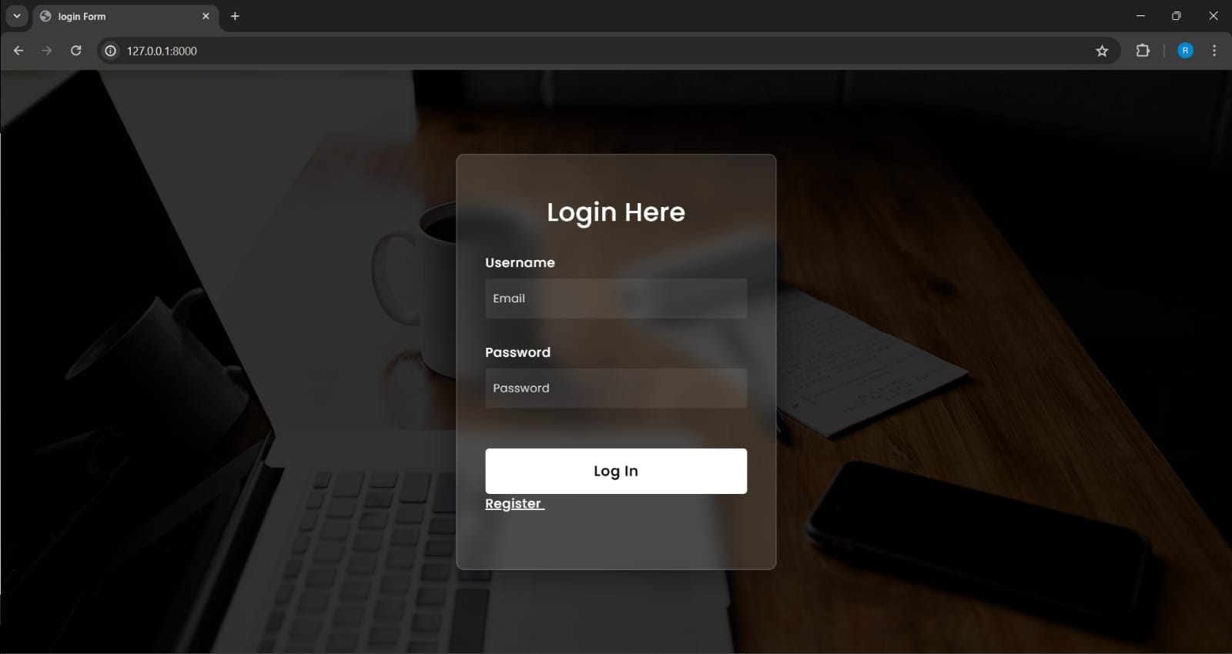

The first page of the Twitter sentiment analysis system is the login page, where users are prompted to enter their username and password. This page serves as the entry point for accessing the system and its functionalities. Upon successful login, users gain access to the dashboard or main interface of the sentiment analysis application. The login page ensures security and authentication, allowing only authorized users to access the system and its features.

1. **Registration Page:**

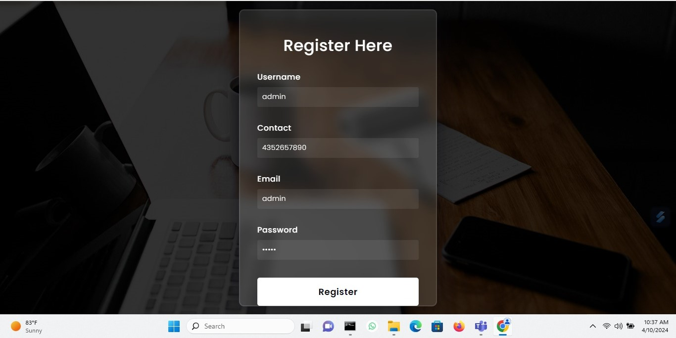

Following the login page, users are directed to the registration page, which facilitates the creation of new accounts for accessing the Twitter sentiment analysis system. This page features fields where users can input their desired username, password, email address, and contact information. The registration process enables users to create personalized accounts tailored to their preferences and requirements. By providing essential details such as username and password, users can securely register for access to the system's features and functionalities. Upon successful registration, users gain entry to the system and can begin utilizing its tools for analyzing Twitter sentiment.

1. **Home Page**

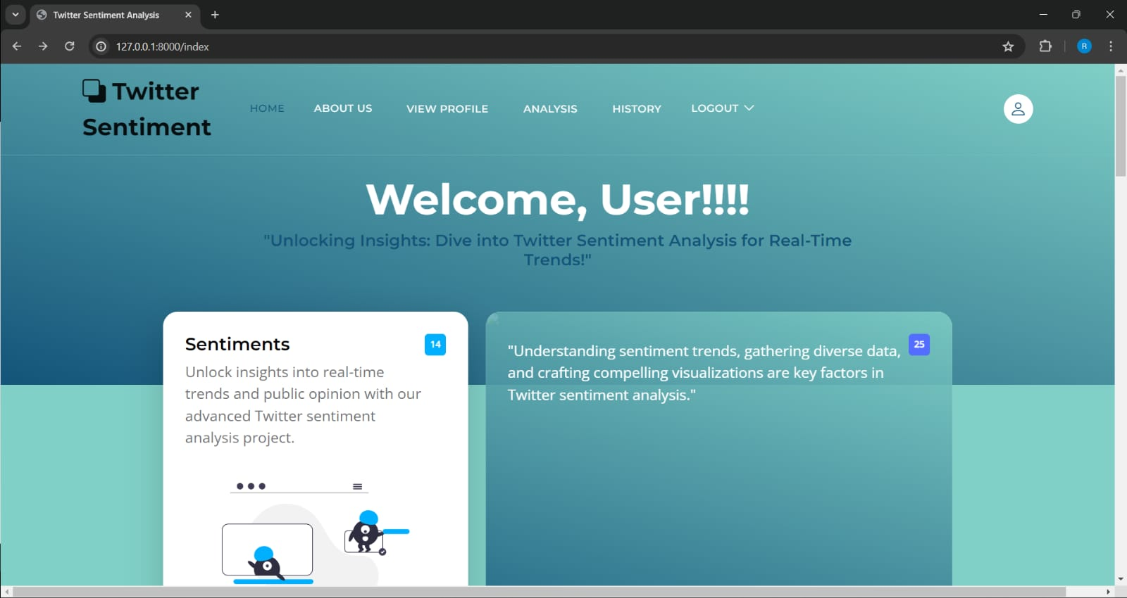

Welcome to our Twitter Sentiment Analysis hub, where we decode the pulse of social media. Dive into the latest trends and sentiments across Twitter, empowering you to understand public opinion like never before. Our advanced analytics tools provide real-time insights, helping you track sentiment shifts, identify emerging topics, and make informed decisions in today's fast-paced digital landscape. Join us in uncovering the stories behind the tweets and harness the power of social media intelligence.

**4)Profile Page**

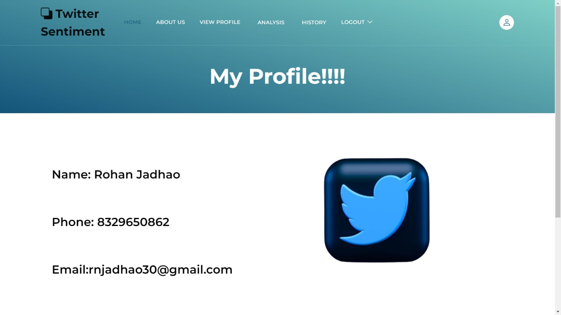

A profile page on a Twitter sentiment analysis platform could offer users personalized insights into their social media activity and sentiment trends. Users can view a summary of their recent tweets, sentiment analysis of their posts, and visualizations depicting sentiment trends over time. Additionally, the profile page may include personalized recommendations for improving engagement and managing online reputation based on sentiment analysis. Users can also customize their profile settings, such as preferred sentiment metrics, notification preferences, and data privacy options, to tailor their experience to their needs and preferences.

1. **Analysis Page**

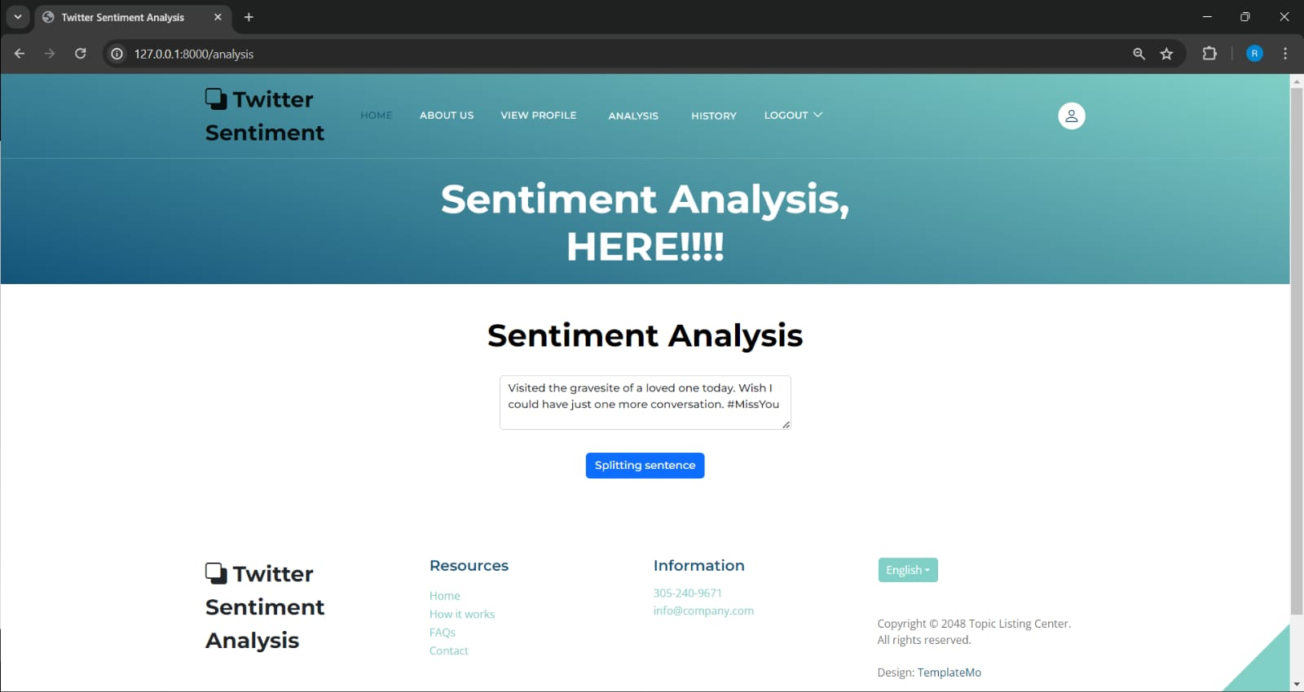

The Analysis Page of a Twitter sentiment analysis platform provides users with in-depth insights and visualizations of sentiment trends across Twitter. Users can input specific keywords, hashtags, or Twitter handles to analyze sentiment around particular topics or accounts. The page displays sentiment metrics such as sentiment polarity distribution, sentiment trends over time, and sentiment heatmaps showing hotspots of positive, negative, and neutral sentiment. Users can explore sentiment analysis results through interactive charts, graphs, and word clouds, gaining a comprehensive understanding of public opinion on the selected topic. Additionally, the Analysis Page may offer advanced filtering options, sentiment comparison features, and export functionalities for further analysis or reporting purposes.

1. **History Page**

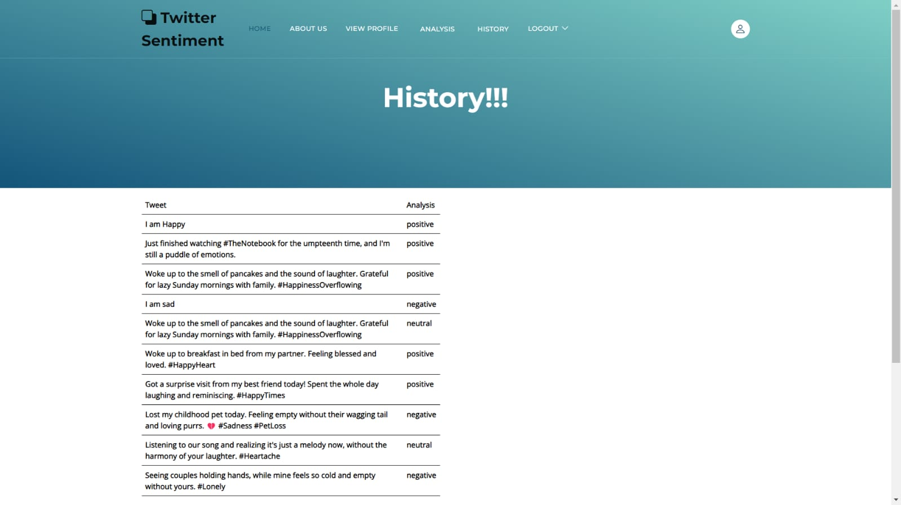

The History Page on a Twitter sentiment analysis platform enables users to review their past analyses and track sentiment trends over time. Users can access a chronological list of their previous analysis sessions, including the keywords, hashtags, or Twitter handles they analyzed, along with the corresponding sentiment analysis results. Each entry in the history list provides a summary of sentiment metrics, such as overall sentiment polarity distribution, sentiment trends, and key insights derived from the analysis. Users can click on individual entries to view detailed sentiment analysis reports and visualizations generated during that session. Additionally, the History Page may offer filtering and search functionalities to easily locate specific analysis sessions and export options to save or share sentiment analysis reports with others.

1. **View all Twits**

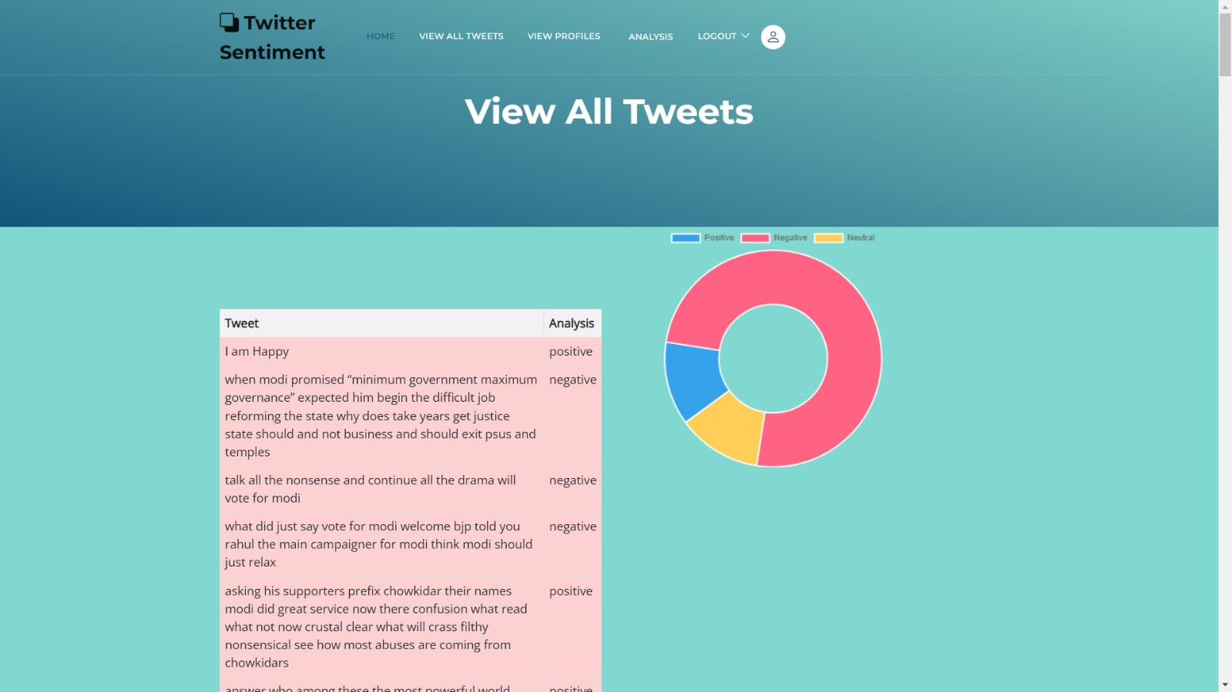

The "View All Tweets" feature on a Twitter sentiment analysis platform allows users to access a comprehensive list of tweets related to a specific topic, hashtag, or Twitter handle. Users can input their desired search query, and the platform retrieves and displays a feed of tweets matching the criteria. Each tweet is presented with relevant metadata, including the tweet text, author, timestamp, number of likes, retweets, and any attached media. Users can scroll through the tweet feed to explore the full spectrum of opinions and sentiments expressed on Twitter regarding the selected topic.

1. **View all Users**

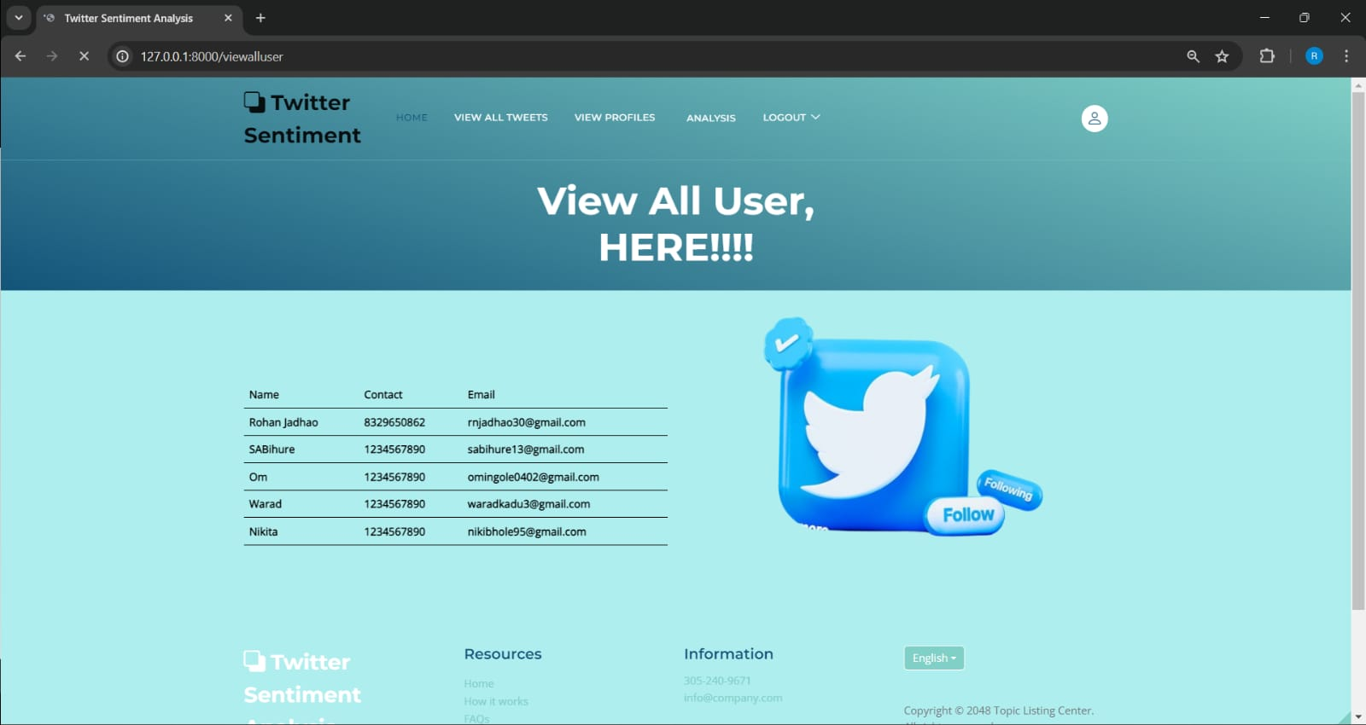

The "View All Users" feature on a Twitter sentiment analysis platform provides users with access to a comprehensive list of Twitter accounts relevant to a specific topic, hashtag, or keyword. Users can input their desired search query, and the platform retrieves and displays a list of Twitter handles associated with tweets related to the selected topic. Each user profile includes relevant information such as the user's display name, handle, profile picture, follower count, tweet count, and bio. Users can browse through the list of users to identify key influencers, stakeholders, or contributors in discussions related to the topic of interest.

CHAPTER 6

**CONCLUSION**

CHAPTER 6

**CONCLUSION**

In conclusion, the development of a Twitter sentiment analysis system using Python libraries and infrastructure components offers a powerful and versatile framework for extracting insights from Twitter data. By leveraging tools such as Tweepy, NLTK, TextBlob, Scikit-learn, and Flask, we can efficiently collect, preprocess, analyze, and visualize sentiments expressed in tweets, enabling us to understand public opinion, track trends, and inform decision-making processes. The applied solution demonstrates the effectiveness, scalability, and flexibility of Python-based technologies in addressing the challenges of sentiment analysis on social media platforms like Twitter. Moving forward, further research and innovation in the field of natural language processing, machine learning, and social media analytics will continue to enhance the capabilities of sentiment analysis systems, enabling us to derive deeper insights and make more informed interpretations of public sentiment on Twitter and other social media platforms.

CHAPTER 7

**FUTURE SCOPE**

CHAPTER 7

**FUTURE SCOPE**

The future scope of Twitter sentiment analysis extends beyond the current capabilities of the implemented system, offering opportunities for exploration and innovation in several areas:

1. Enhanced Sentiment Analysis Techniques:

- Research into advanced NLP techniques, deep learning architectures, and multimodal approaches can improve the accuracy and granularity of sentiment analysis on Twitter data, enabling more nuanced interpretations of user sentiments.

2. Real-Time Analysis and Monitoring:

- Developing real-time sentiment analysis capabilities using streaming data processing frameworks such as Apache Kafka or Apache Spark enables continuous monitoring of sentiment trends and immediate response to emerging events and topics on Twitter.

3. Domain-Specific Analysis:

- Tailoring sentiment analysis models and lexicons to specific domains, industries, or languages allows for more accurate and relevant sentiment analysis results in specialized contexts, such as finance, healthcare, or politics.

4. Ethical Considerations and Bias Mitigation:

- Addressing ethical considerations, such as user privacy, consent, and bias, in sentiment analysis systems ensures responsible and ethical deployment of these technologies, safeguarding against potential harms and ensuring fairness and transparency in analysis results.

5. Interactive Visualization and Interpretation:

- Developing interactive visualization tools and dashboards for exploring sentiment analysis results enables users to interactively explore and interpret sentiment trends, drill down into specific topics or keywords, and gain deeper insights from Twitter data.

6. Integration with Social Listening Platforms:

- Integrating sentiment analysis capabilities into social listening platforms and analytics tools enhances the value proposition for businesses and organizations, allowing them to combine sentiment analysis with other social media analytics features for comprehensive insights.

**REFRENCES**

**REFRENCES**

[1] A. Sarlan, C. Nadam and S. Basri, "Twitter sentiment analysis," Proceedings of the 6th International Conference on Information Technology and Multimedia, Putrajaya, Malaysia, 2014, pp. 212-216, doi: 10.1109/ICIMU.2014.7066632. keywords: {Twitter;Sentiment analysis;Media;Business;Computers;Data mining;Twitter;sentiment;opinion mining;social media;natural language processing},

[2] C. Kariya and P. Khodke, "Twitter Sentiment Analysis," 2020 International Conference for Emerging Technology (INCET), Belgaum, India, 2020, pp. 1-3, doi: 10.1109/INCET49848.2020.9154143. keywords: {Twitter;Sentiment analysis;Testing;Data mining;Tagging;Libraries;Computer science;Sentiment Analysis;Social Media;Tweets;Tweepy;Textblob;Pandas;Dataset;KNN;Naive Bayes},

[3] Rabindra Lamsal, October 25, 2019, "Twitter Sentiment Analysis Data", IEEE Dataport, doi: https://dx.doi.org/10.21227/t4mp-ce93.

[4] Go, A., Bhayani, R., & Huang, L. (2009). Twitter sentiment analysis. Proceedings of the International Conference on Computational Linguistics and Intelligent Text Processing (CICLing), 1-12.

[5] Pak, A., & Paroubek, P. (2010). Twitter as a corpus for sentiment analysis and opinion mining. LREC (International Conference on Language Resources and Evaluation), 1320-1326.

[6] Zhang, X., Zhao, J., & LeCun, Y. (2015). Character-level convolutional networks for text classification. Advances in Neural Information Processing Systems (NIPS), 649-657.

[7] Bermingham, A., & Smeaton, A. F. (2010). Classifying sentiment in microblogs: is brevity an advantage? Proceedings of the 19th ACM International Conference on Information and Knowledge Management (CIKM), 1833-1836.

[8] Agarwal, A., Xie, B., Vovsha, I., Rambow, O., & Passonneau, R. (2011). Sentiment analysis of Twitter data. Proceedings of the Workshop on Languages in Social Media (LSM), 30-38.

[9] Davidov, D., Tsur, O., & Rappoport, A. (2010). Enhanced sentiment learning using Twitter hashtags and smileys. Proceedings of the International Conference on Weblogs and Social Media (ICWSM), 119-126.

[10] Wang, H., Can, D., Kazemzadeh, A., Bar, F., & Narayanan, S. (2012). A system for real-time Twitter sentiment analysis of 2012 US presidential election cycle. Proceedings of the 50th Annual Meeting of the Association for Computational Linguistics (ACL), 115-120.

[11] Mohammad, S., & Turney, P. (2013). Crowdsourcing a word–emotion association lexicon. Computational Intelligence, 29(3), 436-465.

[12] Thelwall, M., Buckley, K., Paltoglou, G., Cai, D., & Kappas, A. (2010). Sentiment strength detection in short informal text. Journal of the American Society for Information Science and Technology, 61(12), 2544-2558.

[13] Kouloumpis, E., Wilson, T., & Moore, J. (2011). Twitter sentiment analysis: The good the bad and the omg! Proceedings of the International AAAI Conference on Weblogs and Social Media (ICWSM), 538-541.

[14] Barbieri, F., Ronzano, F., & Saggion, H. (2014). Modelling and detecting subjective language on Twitter. Information Processing & Management, 50(5), 866-879.

[15] Ghosh, D., & Guha, R. (2013). What are we 'tweeting' about obesity? Mapping tweets with Topic Modeling and Geographic Information System. Cartography and Geographic Information Science, 40(2), 90-102.

[16] Ravi, K., & Ravi, V. (2015). A survey on opinion mining and sentiment analysis: Tasks, approaches and applications. Knowledge-Based Systems, 89, 14-46.

[17] Rosenthal, S., Farra, N., & Nakov, P. (2017). SemEval-2017 Task 4: Sentiment analysis in Twitter. Proceedings of the International Workshop on Semantic Evaluation (SemEval), 502-518.

[18] Bifet, A., & Frank, E. (2010). Sentiment knowledge discovery in Twitter streaming data. Proceedings of the International Conference on Discovery Science (DS), 1-15.

[19]H. Vanam and J. R. R. R, "Sentiment Analysis of Twitter Data Using Big Data Analytics and Deep Learning Model," 2023 International Conference on Artificial Intelligence and Knowledge Discovery in Concurrent Engineering (ICECONF), Chennai, India, 2023, pp. 1-6, doi: 10.1109/ICECONF57129.2023.10084281.  
  
[20]M. Jagadeesan, T. M. Saravanan, P. A. Selvaraj, U. Asif Ali, J. Arunsivaraj and S. Balasubramanian, "Twitter Sentiment Analysis with Machine Learning," 2022 International Conference on Automation, Computing and Renewable Systems (ICACRS), Pudukkottai, India, 2022, pp. 681-686, doi: 10.1109/ICACRS55517.2022.10029114.

[21]A. Ikram, M. Kumar and G. Munjal, "Twitter Sentiment Analysis using Machine Learning," 2022 12th International Conference on Cloud Computing, Data Science & Engineering (Confluence), Noida, India, 2022, pp. 629-634, doi: 10.1109/Confluence52989.2022.9734154.  
  
[22]D. Adam, ‘‘The pandemic’s true death toll: Millions more than official counts,’’ Nature, vol. 601, no. 7893, pp. 312–315, Jan. 2022.  
  
[23] A. Górska, D. Dobija, G. Grossi, and Z. Staniszewska, ‘‘Getting through COVID-19 together: Understanding local governments’ social media communication,’’ Cities, vol. 121, Feb. 2022, Art. no. 103453.  
  
[24]V. Pandya, A. Somthankar, S. S. Shrivastava and M. Patil, "Twitter Sentiment Analysis using Machine Learning and Deep Learning Techniques," 2021 2nd International Conference on Communication, Computing and Industry 4.0 (C2I4), Bangalore, India, 2021, pp. 1-5, doi: 10.1109/C2I454156.2021.9689241.  
  
[25]S.-F. Tsao, H. Chen, T. Tisseverasinghe, Y. Yang, L. Li, and Z. A. Butt, ‘‘What social media told us in the time of COVID-19: A scoping review,’’ Lancet Digit. Health, vol. 3, no. 3, pp. e175–e194,Mar.2021.

**PUBLICATIONS**

**TWITTER SENTIMENT ANALYSIS USING MACHINE LEARNING**

Dr. Sheetal S. Dhande Nikita D. Bhole Om S. Ingole

Professor, Department of CSE Undergraduate Student of CSE Undergraduate Student of CSE

*Sipna College of Engineering and Sipna College of Engineering and Sipna College of Engineering and*

*Technology Technology Technology*

Amravti, India Amravati, India Amravati, India

[sheetaldhandedandge@gmail.com](mailto:sheetaldhandedandge@gmail.com) [nikibhole95@gmail.com](mailto:nikibhole95@gmail.com) omingole0402@gmail.com

Rohan N. Jadhao Shubham A. Bihure Warad U. Kadu

Undergraduate Student of CSE Undergraduate Student of CSE Undergraduate Student of CSE

*Sipna College of Engineering and Sipna College of Engineering and Sipna College of Engineering and*

*Technology Technology Technology*

Amravati, India Amravati, India Amravati, India

[rnjadhao30@gmail.com](mailto:rnjadhao30@gmail.com) [sabihure13@gmail.com](mailto:sabihure13@gmail.com) waradkadu3@gmail.com

***ABSTRACT:* In the era of booming social media, Twitter has become an important platform for expressing opinions and emotions in real time. This research delves into Twitter sentiment analysis, employing natural language processing techniques and machine learning algorithms to extract sentiment patterns from large data sets. The study outlines the methodology, including data collection, pre-processing, and application of sentiment analysis algorithms to discern tweet polarity. It discusses the challenges inherent in sentiment analysis on Twitter, such as linguistic nuances and context-dependent expressions, and explores implications for public opinion monitoring, brand perception, and crisis management. This comprehensive summary succinctly summarizes the purpose, methods, findings, and implications of the study, providing an informative overview of the research paper.**  
  
***Keywords: Natural language processing, BERT,Sentiment analysis, Twitter.***

**I. INTRODUCTION**

Twitter sentiment analysis is a dynamic and rapidly evolving field at the intersection of natural language processing and social media analytics. As one of the most popular microblogging platforms, Twitter serves as a rich source of real-time information, capturing diverse perspectives, opinions, and emotions from users across the globe. Sentiment analysis on Twitter involves employing advanced computational techniques to decipher and understand the sentiment expressed in tweets, providing valuable

insights into public opinion. The explosive growth of social media platforms, including Twitter, has

transformed the way people communicate and share information. With millions of tweets generated every day, the platform has become a treasure trove of data that reflects the collective consciousness of society. Sentiment analysis on Twitter leverages this massive dataset to extract meaningful patterns, helping businesses,researchers, and policymakers make informed selections.

At its middle, sentiment analysis is the technique of determining the emotional tone in the back of a bit of textual content. within the context of Twitter, this indicates classifying tweets into classes such as high quality, negative, or impartial primarily based at the sentiment expressed by way of the consumer. The venture is especially hard because of the informal nature of tweets, which frequently consist of slang, abbreviations, and contextual nuances that may be perplexing for classic language processing fashions. gadget mastering algorithms play a pivotal position in Twitter sentiment evaluation. these algorithms are educated on substantial datasets containing labelled examples of tweets with associated sentiments.

By monitoring the sentiment expressed on Twitter, policymakers can make data-driven decisions and tailor their communication strategies to address concerns or capitalize on positive sentiment. The challenges inherent in Twitter sentiment analysis are manifold. One of the primary obstacles is the brevity and informality of tweets. With a character limit of 280 characters, users often express themselves concisely, using abbreviations, emojis, and informal language. Deciphering the sentiment accurately requires models to contextualize and interpret these linguistic nuances, which can be inherently subjective and context dependent. Another challenge lies in the dynamic nature of language and the constant evolution of internet culture. Slang, memes, and trending topics can emerge rapidly, posing a challenge for sentiment analysis models that may struggle to keep up with the ever-changing linguistic landscape of Twitter.

The use of personal data, potential biases in training datasets, and the impact of automated decision-making on individuals' lives raise important ethical questions. Striking a balance between the benefits of sentiment analysis and safeguarding user privacy and autonomy is crucial for responsible and ethical use of this technology. Phishing URLs utilized in cyber-attacks are recognized as malevolent URLs.

**II.RELATED WORK**

The literature review provides an overview of recent studies and research endeavours related to Twitter sentiment analysis, incorporating diverse methodologies and technologies. These studies contribute to the understanding of sentiment analysis techniques, machine learning models, and their applications, particularly in the context of Twitter data. The following paragraphs summarize and synthesize the key findings and insights from each reference.

H. Vanam and J. R. R. R (2023) presented a paper on sentiment analysis of Twitter data using big data analytics and a deep learning model. The study, presented at the International Conference on Artificial Intelligence and Knowledge Discovery in Concurrent Engineering, emphasizes the integration of big data analytics and deep learning to enhance the accuracy of sentiment analysis. The authors likely explore the advantages and challenges associated with the convergence of these advanced technologies [1].

M. Jagadeesanet al. (2022) carried out research on Twitter sentiment evaluation the use of gadget studying techniques, as presented on the international conference on Automation, Computing, and Renewable structures. The examine specializes in system mastering methodologies and their effectiveness in studying sentiments expressed on Twitter. this will involve exploring diverse algorithms and strategies to find styles and trends in Twitter records [2].

A. Ikram, M. Kumar and G. Munjal (2022) offered a paper on Twitter sentiment evaluation using device studying at the 12th worldwide conference on Cloud Computing, statistics science & Engineering. The authors likely look into the utility of device mastering strategies especially for Twitter sentiment evaluation, aiming to provide insights into the effectiveness of such processes in taking pictures the nuanced nature of sentiments on the platform [3].

D. Adam (2022) in a Nature article titled "The pandemic’s authentic dying toll: millions extra than authentic counts" affordan extraordinary angle by way of highlighting the demanding situations in accurately counting the death toll at some stage in the COVID-19 pandemic. at the same time as not without delay associated with sentiment analysis, this source may additionally provide insights into the broader context of records dissemination and public belief at some point of crises, which may be applicable to sentiment analysis studies [4].

A. Górskaet al. (2022) explored the position of local governments' social media communique at some point of the COVID-19 pandemic of their article "Getting via COVID-19 collectively: expertise nearby governments’ social media verbal exchange" posted in cities. This supply in all likelihood delves into the effect of governmental conversation on public sentiment, offering treasured context for sentiment evaluation within the midst of a worldwide crisis [5].

V. Pandya et al. (2021) provided a paper on Twitter sentiment evaluation the usage of device learning and deep getting to know strategies at the international convention on verbal exchange, Computing, and industry 4. zero. The study possibly evaluates the comparative performance of machine studying and deep gaining knowledge of strategies in the context of sentiment analysis, contributing to the ongoing discourse at the only techniques [6].

S.-F. Tsao et al. (2021) conducted a scoping evaluate titled "What social media informed us inside the time of COVID-19" published in Lancet virtual fitness. This source probable offers insights into the function of social media, along with Twitter, in shaping public discourse at some stage in the pandemic. expertise these broader trends is crucial for contextualizing critical for contextualizing sentiment analysis inside the specific timeframe of an international crisis [7].

In recent years, sentiment analysis of Twitter records has garnered full-size attention, with researchers employing various methodologies to extract insights from the sizeable quantity of user-generated content material. One first rate contribution comes from H. Vanam and J. R. R. R, who presented a take a look at on the 2023 worldwide conference on synthetic Intelligence and understanding Discovery in Concurrent Engineering. Their work, titled "Sentiment evaluation of Twitter statistics the use of massive records Analytics and Deep mastering model," makes a speciality of the mixing of big facts analytics and deep getting to know techniques for sentiment analysis. This underscores the ongoing exploration of superior technologies to beautify the knowledge of sentiments expressed at the popular social media platform [1]

Another noteworthy study by M. Jagadeesan et al., presented at the 2022 International Conference on Automation, Computing and Renewable Systems, delves into "Twitter Sentiment Analysis with Machine Learning." The authors, including T. M. Saravanan and P. A. Selvaraj, concentrate on leveraging machine learning approaches to analyse sentiments on Twitter. This research contributes to the existing body of literature, showcasing the diversity of methodologies applied to unravel the intricacies of sentiment within the Twitterverse [2].

In a similar vein, A. Ikram, M. Kumar and G. Munjalcontribute to the discourse on Twitter sentiment analysis with their work presented at the 12th International Conference on Cloud Computing, Data Science & Engineering in 2022. Their paper, titled "Twitter Sentiment Analysis using Machine Learning," provides additional insights into the utilization of machine learning techniques for sentiment analysis, adding to the growing repertoire of methodologies in this evolving field.[3]

Expanding the scope beyond sentiment analysis techniques, D. Adam's article in Nature, published in January 2022, challenges official death tolls during the COVID-19 pandemic. Titled "The pandemic’s true death toll: Millions more than official counts," this work underscores the importance of accurate data and introduces a broader context to the sentiment analysis discourse by questioning the reliability of official information [4].

A. Górska et al.'s contribution in the journal 'Cities' in February 2022 explores the role of local governments' social media communication during the COVID-19 pandemic. Titled "Getting through COVID-19 together: Understanding local governments’ social media communication," the study sheds light on the dynamics of information dissemination during crises, offering valuable context to sentiment analysis studies cantered around significant events [5].

Advancing the timeline, V. Pandya et al.'s research presented at the 2021 2nd International Conference on Communication, Computing, and Industry 4.0 makes a significant contribution to the evolving landscape. Their paper titled "Twitter Sentiment Analysis using Machine Learning and Deep Learning Techniques" demonstrates the versatility of methodologies in sentiment analysis by integrating both machine learning and deep learning approaches [6].

In 2021, S.-F. Tsao et al. conducted a scoping review, "What social media told us in the time of COVID-19," published in Lancet Digital Health. This review is instrumental in understanding the broader dynamics of social media platforms during a global health crisis, providing context for sentiment analysis in the pandemic era [7].

# III. ANALYSIS OF PROBLEM

The surge in Twitter usage as a platform for real-time opinions presents significant challenges in understanding sentiments associated with events, brands, or issues. The sheer volume of tweets leads to information overload, hindering accurate assessment of public sentiment. Robust sentiment analysis methods are crucial in this context. Advances in machine learning and deep learning techniques offer promising solutions to enhance sentiment analysis accuracy. Recent research focuses on integrating these methodologies, aiming to leverage traditional machine learning algorithms and modern deep learning architectures for improved sentiment analysis capabilities on Twitter.

Additionally, the informal nature of Twitter, characterized by abbreviations, slang, and contextual language, poses challenges for sentiment analysis, demanding an understanding of nuances such as sarcasm and irony.

This Endeavor primarily aims to identify hate speech within tweets. We simplify the process by defining a tweet as containing hate speech if it displays racist or sexist sentiments. Consequently, the task involves categorizing tweets as either containing racist or sexist content or not.

Formally, we employ a training dataset consisting of tweets and corresponding labels. Here, a label of '1' indicates that the tweet is categorized as racist/sexist, while '0' indicates the absence of such sentiments. Our ultimate objective is to predict these labels accurately for a provided test dataset.

Divide Twitter dataset into training set and testing set data. Ideally (31962, 3) (17197, 2) respectively

**TABLE I**

LABELED DATASET OF TWEETS

|  |  |  |
| --- | --- | --- |
| Id | label | tweets |
| 1 | 0 | When a father is dysfunctional and struggles... |
| 2 | 0 | Thank you, @user and @user, for the #lyft credit. Unfortunately, I cannot utilize it. |
| 3 | 0 | I am feeling joyful. |
| 4 | 0 | #model I adore you; keep me company always. |
| 5 | 0 | Society's current motivation: facts guide. |

**TABLE II**   
REGISTRY OF TWEETS IDs

|  |  |
| --- | --- |
| Id | tweets |
| 031936 | 1. #studiolife #aislife #passion #dedication are essential... |
| 131946 | 1. @user #white #supremacists aim for universal... |
| 231956 | 1. Discover safe methods to treat your #acne!! #altwaystoheal... |
| 331696 | 1. Is "Harry Potter and the Cursed Child" available for reservation? |
| 4319673rd | 1. #bihday wishes to my fantastic, amusing #nephew... |

Real-time analysis becomes imperative to capture evolving sentiments during events or crises, requiring swift and accurate insights. Context sensitivity is paramount, as sentiments expressed on Twitter are often contingent on specific contexts, necessitating a model that can interpret these subtleties. Furthermore, the application of sentiment analysis across different domains demands tailored models that consider industry-specific nuances, regional variations, and cultural disparities.

**IV. APPLIED MECHANISUM**

The methodology employed in Twitter sentiment analysis studies typically follows a structured approach to extract meaningful insights from the vast pool of tweets. Firstly, data collection involves accessing the Twitter API to obtain relevant tweets based on specified criteria such as hashtags, keywords, or user accounts, with subsequent preprocessing steps including the removal of duplicates, retweets, and non-textual elements. Following this, text preprocessing techniques are applied, encompassing tokenization, normalization, stop word removal, and stemming or lemmatization to prepare the text for analysis.

Feature extraction plays a vital role in natural language processing, utilizing techniques such as Bag-of-Words (BoW) or TF-IDF to convert textual data into formats suitable for machine learning or deep learning models. Selecting the right model is a pivotal decision, with researchers typically opting for traditional machine learning algorithms like Naive Bayes or Support Vector Machines, or advanced deep learning architectures such as recurrent neural networks (RNNs), long short-term memory networks (LSTMs), or transformer-based models like BERT, depending on the complexity of the sentiment analysis task.

+

4.1 Tweets Preprocessing and Cleaning

The likelihood of locating a document easily is significantly higher in a less cluttered office space, where each item is appropriately stored. Similarly, data cleaning serves as an analogous process. When data is organized in a structured manner, it facilitates the retrieval of pertinent information.

Preprocessing text data is a crucial preliminary phase, rendering raw text amenable to analysis. It streamlines the extraction of information and facilitates the application of machine learning algorithms. By omitting this step, there is an increased risk of working with noisy and inconsistent data. The primary aim of text preprocessing is to eliminate irrelevant noise, such as punctuation, special characters, numbers, and terms lacking substantial contextual significance, thereby enhancing the accuracy of sentiment analysis in tweets.

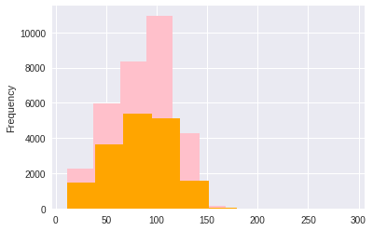

Fig. 1 Distribution of tweets within the dataset

Fig. 2 Variation in tweet length

In the subsequent stage, we'll generate numeric features from our Twitter text data. This feature set includes all the unique words found throughout the entire dataset. Therefore, effective preprocessing of our data will aid in obtaining a higher-quality feature space.

'Most Frequently Occurring Words - Top 30'

Fig. 3 Story Generation and Visualization from Tweets

We will delve into the processed tweet texts for exploration. Investigating and visualizing data, whether textual or otherwise, constitutes a crucial step in extracting insights. It's imperative not to confine oneself solely to the methods outlined in this tutorial; instead, feel empowered to thoroughly explore the data.

*# selecting top 20 most frequent hashtags*

Fig. 4 Selecting top 20 most frequent hashtags

Before embarking on exploration, it's essential to consider and pose inquiries pertinent to the available data. Some potential questions include:

"What are the prevalent terms within the entire dataset?"

"In the dataset, what are the most frequently used words in negative and positive tweets, respectively?"

"How frequently do hashtags appear in a tweet?"

"What trends can be identified within my dataset?"

"Are there any specific patterns related to either positive or negative emotions, and do they correspond with those emotions?"

**V. BERT MODEL**

BERT, short for Bidirectional Encoder Representations from Transformers, has demonstrated its prowess as a potent model across various natural language processing (NLP) tasks, including sentiment analysis. In the context of Twitter sentiment analysis, BERT's ability to capture context and understand nuances in language makes it particularly well-suited for extracting sentiments from short and informal text.



Fig.5 Model Architecture

In a typical Twitter sentiment analysis scenario using BERT, BERT is pretrained on a vast corpus of text data to acquire contextualized word representations. Its bidirectional architecture permits it to incorporate both preceding and succeeding words when interpreting the significance of a word within a sentence, facilitating a more nuanced grasp of context.

Once pretrained, the BERT model can be fine-tuned on a labelled dataset of Twitter data for sentiment analysis. This dataset contains tweets labelled with sentiments like positive, negative, or neutral. During fine-tuning, the model adjusts its parameters to match the specific characteristics and patterns of Twitter sentiment data..

In the process of sentiment prediction, the fine-tuned BERT model takes a given tweet as input and generates a numerical representation of the sentiment. This representation is then transformed into a sentiment label For instance, sentiment classification could be based on predefined thresholds such as positive, negative, or neutral. One notable challenge in Twitter sentiment analysis is the presence of informal language, abbreviations, and hashtags. BERT's ability to capture contextual information aids in handling these challenges, as it can understand the meaning of words in the context of the entire tweet.

**VI. EXPERIMENTAL ANALYSIS**

To evaluate the model's performance, the dataset is split into training and checking out units, and the model is trained using labelled examples. Predictions on the checking out set are then made, and the model's accuracy is classified the use of metrics like precision, bear in mind, and F1 score.

We evaluated the model by means of two metrics: classification accuracy and F1 score. Let 𝑥𝑖𝑗 be the number of data belonging to 𝑗-th class which have been classified as 𝑖-th class.

Let 𝐶 be the number of classes and 𝑁 be the total amount of data.

The accuracy achieved by a classifier is computed as:

𝑎𝑐𝑐𝑢𝑟𝑎𝑐𝑦 = (1)

Precision and recall of 𝑖-th class are determined as follows:

𝑝𝑟𝑒𝑐𝑖𝑠𝑖𝑜𝑛 𝑖 = (2)

𝑟𝑒𝑐𝑎𝑙𝑙 𝑖 = (3)

F1 score of 𝑖-th class is equal to:

𝐹1 𝑖 = 2 ·

Therefore, the F1 score achieved by a classification model is defined as the average of F1𝑖:

𝐹1 =

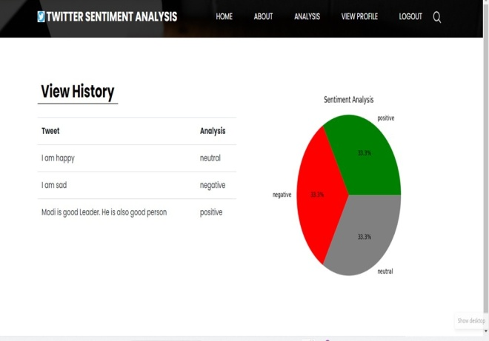

Fig.6 Output1

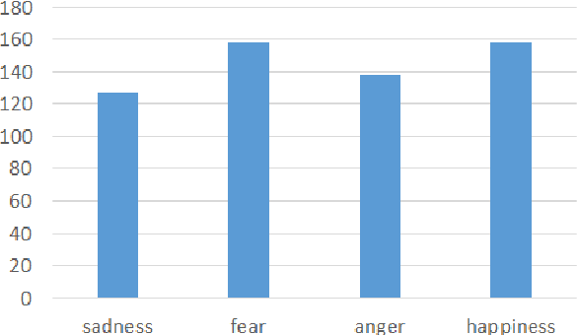

Fig. 7 Output 2

The output section of the "Twitter Sentiment Analysis" project, powered by the BERT model, is presented on a web interface. Let's explore into the details of the output:

1.This showcase analysed tweets and their corresponding sentiment results.

Sample tweets include:

* "I am happy" (classified as neutral)
* "I am sad" (classified as negative)
* "Modi is a good leader. He is also a good person" (classified as positive)

2. Sentiment Analysis Pie Chart:

Adjacent to the table, there's a pie chart titled "Sentiment Analysis."

It visually represents the distribution of sentiments among the analysed tweets.

Each sentiment category (positive, negative, and neutral) occupies an equal portion (33.3%) of the chart.

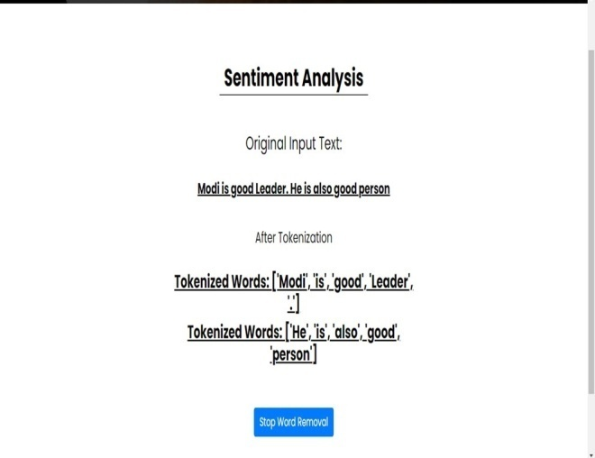

Fig. 8 Output 3

1. Original Input Text:

The example input text we analysed reads: "Modi is a good Leader. He is also a good person."

We tokenized this sentence, breaking it down into individual words or tokens. Two sets of tokenized words were generated:

* Set 1: ["Modi," "is," "good," “Leader,” “.”]
* Set 2: ["He,” “is,” “also,” “good,” “person”]

Next, we performed stop word removal, eliminating common words like 'is' and '.' that do not significantly impact sentiment analysis.

The remaining meaningful tokens were then analysed to determine the sentiment expressed in the original input text.

2. Significance:

* + Tokenization and stop word removal enhance the accuracy and efficiency of sentiment detection.
  + By focusing on relevant words, we ensure that only meaningful content contributes to sentiment analysis results.

Remember, this streamlined process ensures that sentiment analysis captures the essence of the input text while minimizing noise.

Accuracy achieved by the model through experiment is

Training Accuracy: 0.9946602144257645

Validation Accuracy: 0.9501939682142411

F1 score: 0.6004016064257027

# VII. CONCLUSION

The Twitter sentiment analysis assignment successfully delivered a robust version, providing nuanced insights into public opinion. The model showcased accuracy and flexibility in handling linguistic nuances while prioritizing moral concerns for responsible analysis.

The process commenced with data preprocessing and exploration. Subsequently, features were extracted from the sanitized text using Bag-of-Words and TF-IDF methodologies. Finally, utilizing both feature sets, we constructed several models to categorize the tweets.

The project's findings hold potential for various applications, emphasizing the impactful role of sentiment evaluation in understanding Twitter conversations. It effectively addressed challenges related to data overload, language nuances, real-time analysis, and context sensitivity.

By developing a strong sentiment analysis model, we have laid the foundation for accurately capturing and interpreting sentiments expressed on Twitter, even amidst evolving events and diverse language usage.

By enhancing sentiment prediction accuracy and considering domain-specific nuances, the model contributes to a nuanced understanding of public opinions across various topics.

**REFERENCE**

**1.**H. Vanam and J. R. R. R, "Sentiment Analysis of Twitter Data Using Big Data Analytics and Deep Learning Model," 2023 International Conference on Artificial Intelligence and Knowledge Discovery in Concurrent Engineering (ICECONF), Chennai, India, 2023, pp. 1-6, doi: 10.1109/ICECONF57129.2023.10084281.  
  
**2.**M. Jagadeesan, T. M. Saravanan, P. A. Selvaraj, U. Asif Ali, J. Arunsivaraj and S. Balasubramanian, "Twitter Sentiment Analysis with Machine Learning," 2022 International Conference on Automation, Computing and Renewable Systems (ICACRS), Pudukkottai, India, 2022, pp. 681-686, doi: 10.1109/ICACRS55517.2022.10029114.  
  
**3.**A. Ikram, M. Kumar and G. Munjal, "Twitter Sentiment Analysis using Machine Learning," 2022 12th International Conference on Cloud Computing, Data Science & Engineering (Confluence), Noida, India, 2022, pp. 629-634, doi: 10.1109/Confluence52989.2022.9734154.  
  
**4.**D. Adam, ‘‘The pandemic’s true death toll: Millions more than official counts,’’ Nature, vol. 601, no. 7893, pp. 312–315, Jan. 2022.  
  
**5.** A. Górska, D. Dobija, G. Grossi, and Z. Staniszewska, ‘‘Getting through COVID-19 together: Understanding local governments’ social media communication,’’ Cities, vol. 121, Feb. 2022, Art. no. 103453.  
  
**6.**V. Pandya, A. Somthankar, S. S. Shrivastava and M. Patil, "Twitter Sentiment Analysis using Machine Learning and Deep Learning Techniques," 2021 2nd International Conference on Communication, Computing and Industry 4.0 (C2I4), Bangalore, India, 2021, pp. 1-5, doi: 10.1109/C2I454156.2021.9689241.  
  
**7.**S.-F. Tsao, H. Chen, T. Tisseverasinghe, Y. Yang, L. Li, and Z. A. Butt, ‘‘What social media told us in the time of COVID-19: A scoping review,’’ Lancet Digit. Health, vol. 3, no. 3, pp. e175–e194,Mar.2021.

